Talk Homework
At St. Clare’s we recognise the importance of speaking and listening skills therefore we set talking homework for you and your family to complete with your child. Please discuss these talking points and complete the activities with your child. You don’t need to return this homework to school.
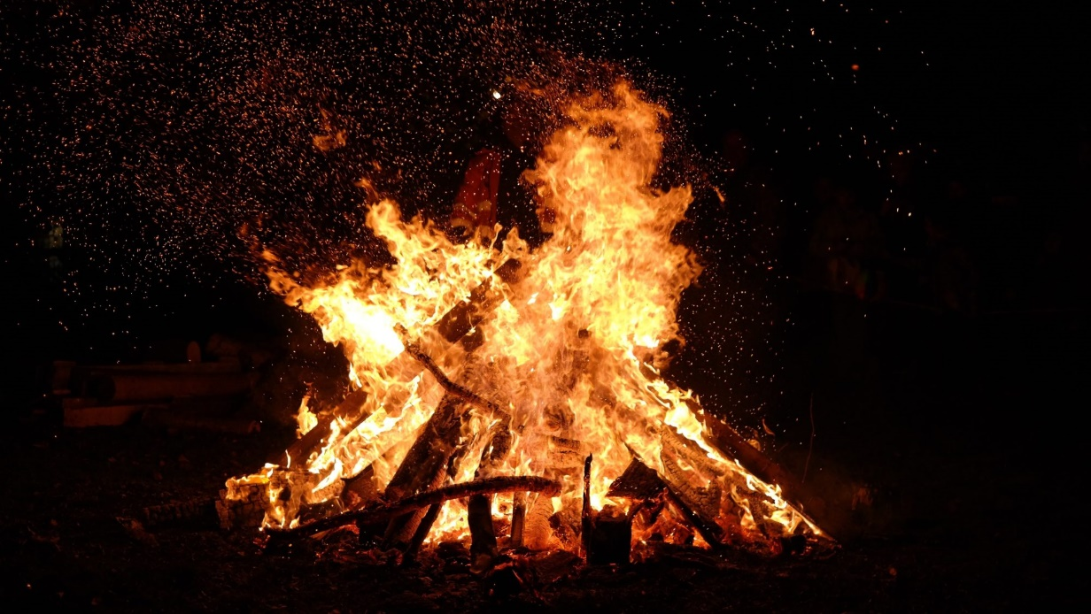
How do people celebrate Bonfire night?

Have you been to a bonfire? What do you see? What did you hear? Could you feel anything?

What rules do you think need to be followed at Bonfire night celebrations?

What do people eat on Bonfire night?

Do you know why people celebrate Bonfire night?

