Talk Homework
At St. Clare’s we recognise the importance of speaking and listening skills therefore we set talking homework for you and your family to complete with your child. Please discuss these talking points and complete the activities with your child. You don’t need to return this homework to school.
What happens in Autumn?

Which animals do we see in Autumn?
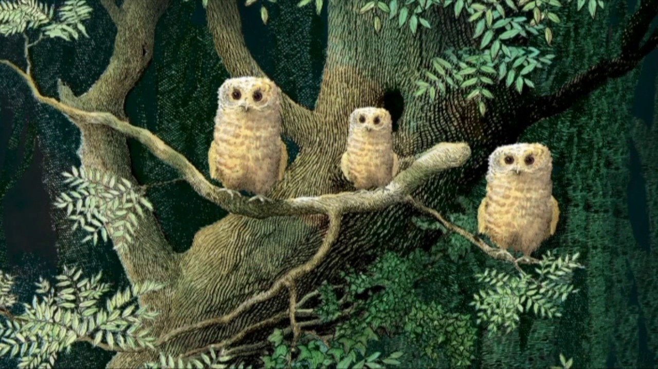
Which animals go to sleep during Winter? Do you know what that is called?

Which animals come out at night? Do you know what that is called?

Can you tell me what happens in the ‘Owl Babies’ story?

What do the different characters say?

