Talk Homework
At St. Clare’s we recognise the importance of speaking and listening skills therefore we set talking homework for you and your family to complete with your child. Please discuss these talking points and complete the activities with your child. You don’t need to return this homework to school.

Can you name the characters in the story?
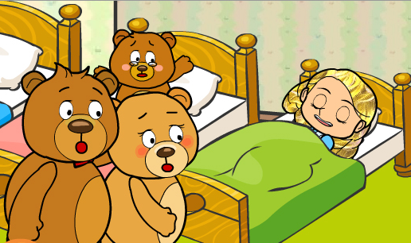
What does Goldilocks do in the story?

Why do you think she is called Goldilocks?

What did she try in the Bears’ house and what happened?

How would you describe Goldilocks? Is she kind and caring?

How would you feel if Goldilocks came to your house?

