Talk Homework
At St. Clare’s we recognise the importance of speaking and listening skills therefore we set talking homework for you and your family to complete with your child. Please discuss these talking points and complete the activities with your child. You don’t need to return this homework to school.
Can you share the story of the three little pigs? What did each character say? What do you think each character is thinking?
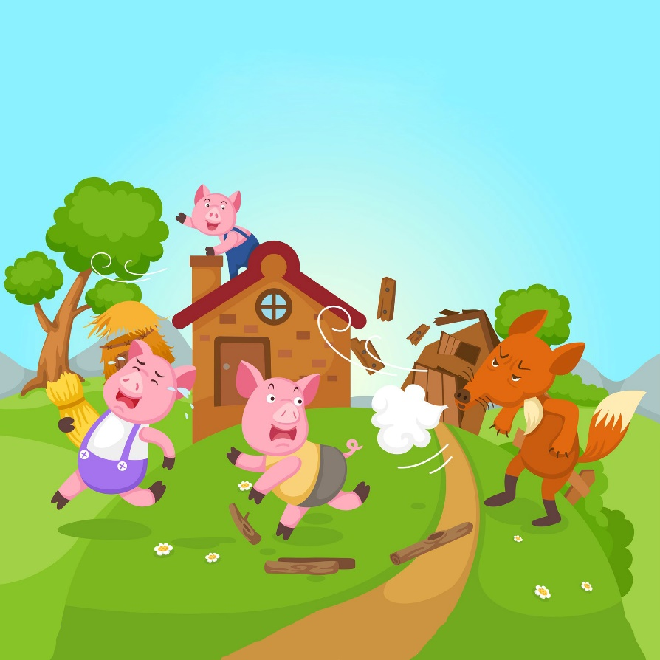
What happened to each house and why?

What are houses made from today and why? What shapes can you see in your own home?

Whose house do you think would be the largest?

Which material do you think would be the heaviest?

Can you build different size houses out of different materials? Which house was the strongest?

