Talk Homework
At St. Clare’s we recognise the importance of speaking and listening skills therefore we set talking homework for you and your family to complete with your child. Please discuss these talking points and complete the activities with your child. You don’t need to return this homework to school.

Which minibeasts did you see and hold at the ‘Creepy Crawly Roadshow’?

Can you retell the story Sam’s Sandwich? Which minibeasts would you put on a sandwich to scare your family?

Can you look for minibeasts together in your home, garden or the nearest park? What did you find?
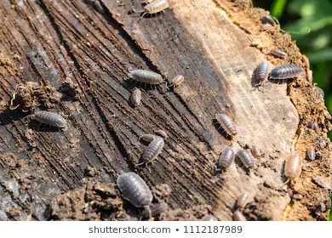
How do different minibeasts protect themselves from predators?

Can you describe the metamorphosis of a caterpillar?

